**SAPARBEK IMANZHUSIP SE-2226**

**Packet Tracer - Use the ipconfig Command**

### **Part 1: Verify Configurations**

**Access Command Prompt**:

On each of the four PCs, I accessed the Command Prompt through the Packet Tracer interface.

**Run ipconfig /all**:

I entered the command ipconfig /all at the command prompt on each PC to display their respective IP configurations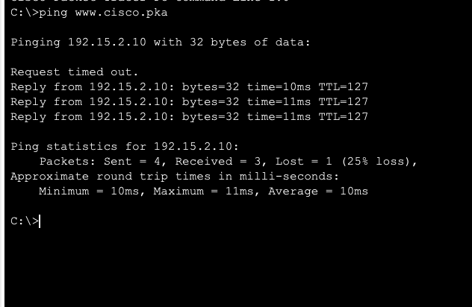

**Record Configuration**:

I documented the IP address, subnet mask, and default gateway for each PC. This allowed me to compare configurations and identify any that did not match the network specifications.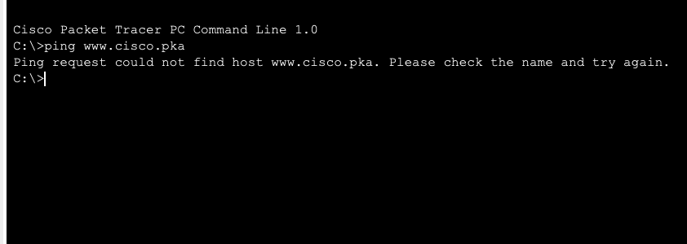

**Identify Incorrect Configuration**:

After reviewing the IP configurations, I identified one PC with an incorrect setting. The expected configuration for the 192.168.1.0/24 network should be:

**IP Address**: Unique address within 192.168.1.1 - 192.168.1.254

**Subnet Mask**: 255.255.255.0

**Default Gateway**: 192.168.1.1 (assuming this is the network’s gateway IP)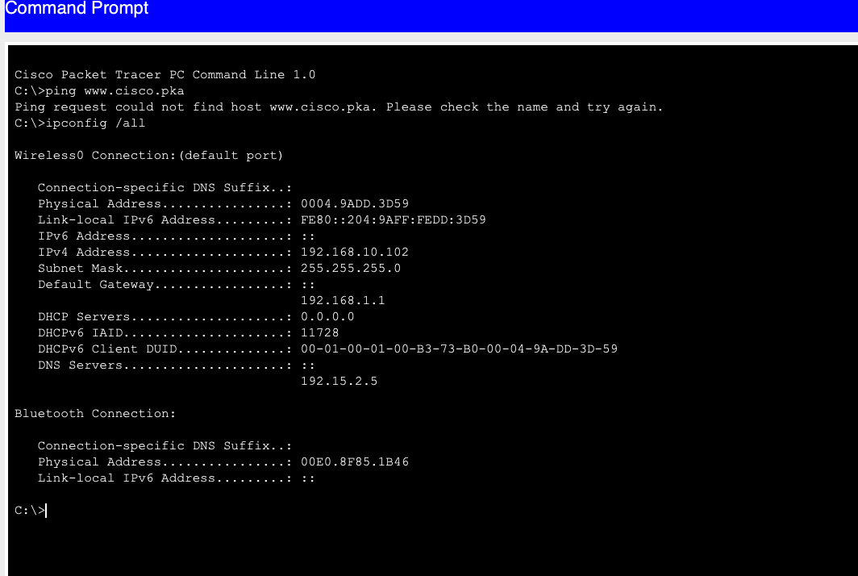

The incorrectly configured PC had either a mismatched IP address (outside the range), a different subnet mask, or an incorrect default gateway.

### **Part 2: Correct Any Misconfigurations**

**Select the Incorrect PC**:

After identifying the PC with the incorrect configuration, I selected it for reconfiguration.

**Correct IP Settings**:

I navigated to the **Desktop** tab and opened the **IP Configuration** tab.

Based on the documented correct settings, I adjusted the IP address, subnet mask, and default gateway to ensure they conformed to the 192.168.1.0/24 network requirements.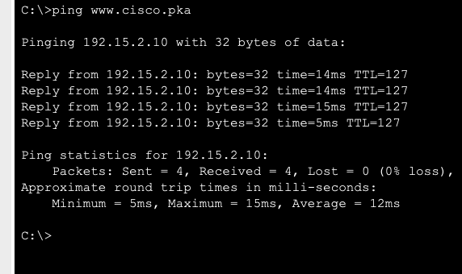

**Verify Connection**:

After making the corrections, I tested the PC’s connectivity by attempting to ping the local webserver ([www.cisco.pka](http://www.cisco.pka)) and verifying internet connectivity.

### **Conclusion:**

The use of the ipconfig /all command was effective in identifying and correcting the misconfiguration on the PC. Ensuring all PCs on the network had consistent IP settings allowed the entire network to connect to the internet and access internal resources. By following these steps, I ensured that all PCs in the office could operate seamlessly within the 192.168.1.0/24 network and access required online resources.

